
ASSIGNMENT 1 – CO1
Design, Build and Validate a Data Warehouse and OLAP Reporting Solution for FreshCart Retail Analytics
KARANYA S
192421309
TASK 1 – Analyse the Decision-Support Requirement (4 Marks)
1.1 Introduction
FreshCart Retail operates 120 supermarkets across six states. Its operational database stores daily transactions such as orders, order lines, customers, products, stores, promotions, and returns.
The existing OLTP database is designed mainly for transaction processing. Management requires historical analysis, sales comparisons, regional performance, customer behaviour analysis, and promotion effectiveness.
A separate Data Warehouse is required to support these analytical activities without affecting billing operations.
1.2 Business Questions with Measures and Dimensions
No. | Business Question | Type | Measures | Dimensions
1 | Which product categories show declining net sales quarter over quarter? | Strategic | Net Sales | Product, Time, Region
2 | Which promotions increased average basket value? | Tactical | Basket Value, Sales | Promotion, Store, Time
3 | How do weekend sales differ from weekday sales? | Tactical | Total Sales | Date, Product, Store
4 | Which customer segments return the most items? | Strategic | Return Quantity | Customer, Product, Time
5 | What is the YTD sales of each store compared with last year? | Strategic | Sales Amount | Store, Time
6 | Which stores generate the highest revenue? | Strategic | Net Sales | Store, Region, Time
7 | Which products have the highest sales quantity? | Tactical | Quantity Sold | Product, Store, Time
8 | Which regions have the highest average transaction value? | Strategic | Average Basket Value | Region, Time, Customer
1.3 Operational System vs Decision-Support System
Feature | OLTP | Data Warehouse / DSS
Purpose | Daily transactions | Management analysis
Data | Current operational data | Historical integrated data
Structure | Normalized tables | Dimensional model
Query | Insert, update, delete | Aggregation and analysis
Users | Cashiers, operational staff | Managers, analysts
Volume | Individual transactions | Millions of historical records
Performance | Fast transactions | Fast analytical queries
Data updates | Continuous | Periodic ETL
1.4 Why FreshCart Requires a Data Warehouse
FreshCart's operational database cannot efficiently support complex analytical queries because:
- Historical data analysis requires joining many normalized tables.
- Analytical queries can slow down billing counters.
- Different departments may calculate net sales differently.
- Large aggregations increase query execution time.
- OLTP systems are optimized for transactions rather than reporting.
- Historical customer address and loyalty changes are difficult to analyse.
- Regional and quarterly comparisons require integrated historical data.
Conclusion
A separate Enterprise Data Warehouse is necessary for FreshCart to provide consistent, accurate, historical and high-performance analytical reporting.
TASK 2 – Propose the Warehouse Architecture (3 Marks)
2.1 Proposed Architecture
FreshCart uses a Three-Tier Data Warehouse Architecture with a centralized Enterprise Data Warehouse and dependent data marts.
Snowflake vs Redshift vs Bigquery and Other Data Warehouses
altexsoft.com
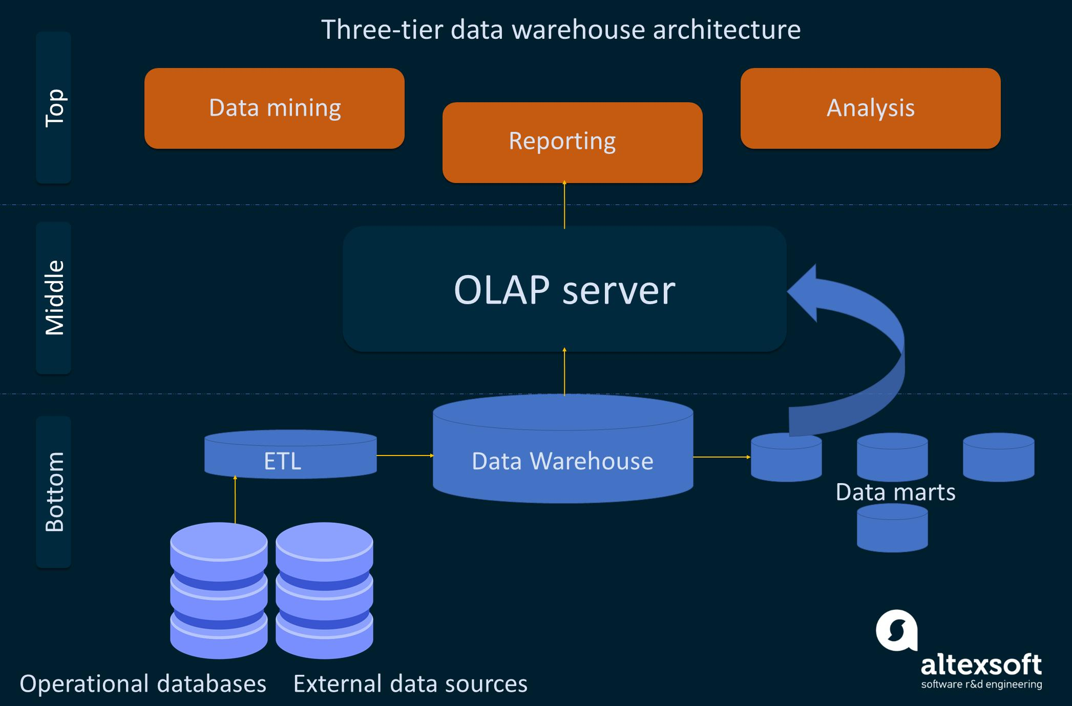
2.2 Architecture Components
- Data Sources: Orders, OrderLines, Customers, Products, Stores, Employees, Promotions, Suppliers and Returns.
- Staging Area: Temporary storage for extracted source data.
- ETL Process: Extracts, cleans, transforms and loads data.
- Enterprise Data Warehouse: Stores integrated historical information.
- Data Marts: Sales, Marketing, Customer and Inventory data marts.
- OLAP Server: Supports multidimensional analysis and aggregation.
- Front-End Tools: KNIME, Power BI, Metabase and SQL reporting tools.
- Metadata Repository: Stores schema definitions, mappings, data lineage and transformation rules.
2.3 Architecture Selection
FreshCart selects a Dependent Data Mart Architecture.
The Enterprise Data Warehouse acts as the central repository, and departmental data marts are created from it.
Advantages:
- Provides a single consistent source of information.
- Avoids duplication of business rules.
- Supports all 120 stores and six states.
- Integrates data from multiple operational systems.
- Enables historical analysis.
- Supports scalable reporting.
Conclusion
The dependent data mart architecture is suitable because FreshCart requires centralized data integration and consistent reporting across departments.
TASK 3 – Design the Star Schema (6 Marks)
3.1 Business Process
The selected business process is Retail Sales Analysis.
3.2 Grain of the Fact Table
The grain of FactSales is:
One row represents one product line item in one customer order at one store on one date under one promotion.
All measures and dimensions are consistent with this grain.
3.3 Star Schema Diagram
Power BI Data Model: Create Data Models
metisbi.co.uk
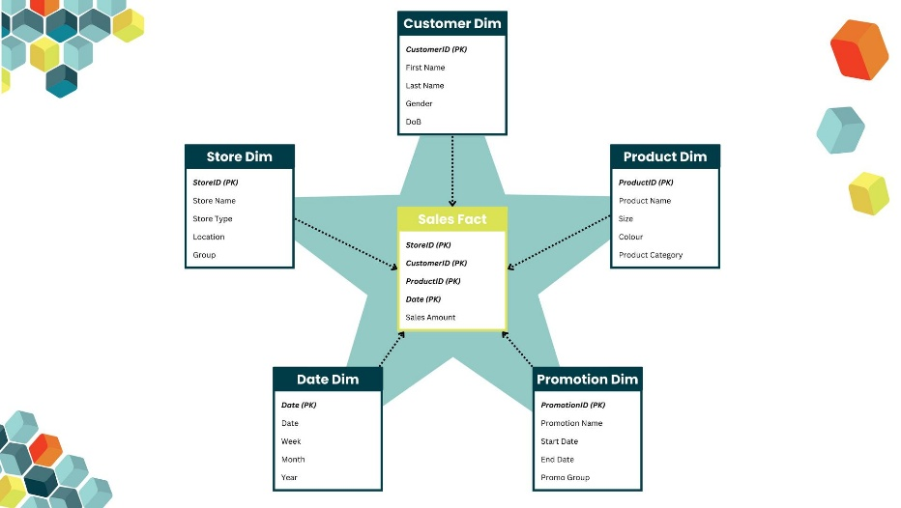
3.4 Fact Table
FactSales
Column | Description
Sales_Key | Primary key
Date_Key | Foreign key
Product_Key | Foreign key
Store_Key | Foreign key
Customer_Key | Foreign key
Promotion_Key | Foreign key
Order_ID | Transaction identifier
Quantity | Quantity sold
Unit_Price | Price per unit
Gross_Sales | Quantity × Unit Price
Discount | Discount amount
Net_Sales | Gross Sales − Discount
Measure Classification
Measure | Classification | Reason
Quantity | Additive | Summed across dimensions
Gross Sales | Additive | Summed across dimensions
Discount | Additive | Summed across dimensions
Net Sales | Additive | Summed across dimensions
Unit Price | Non-additive | Cannot be directly summed
3.5 Dimension Tables
DimDate
Attribute | Description
Date_Key | Primary key
Full_Date | Actual date
Day | Day number
Month | Month
Quarter | Quarter
Year | Year
Weekday | Day of week
Hierarchy:
Day → Month → Quarter → Year
DimProduct
Attribute | Description
Product_Key | Primary key
Product_ID | Business identifier
Product_Name | Product name
Brand | Brand name
Category | Product category
Department | Department
Hierarchy:
Product → Category → Department
DimStore
Attribute | Description
Store_Key | Primary key
Store_ID | Business identifier
Store_Name | Store name
City | City
State | State
Region | Region
Hierarchy:
Store → City → State → Region
DimCustomer
Attribute | Description
Customer_Key | Primary key
Customer_ID | Business identifier
Customer_Name | Customer name
Gender | Gender
Age_Group | Age category
Segment | Customer segment
Address | Customer address
DimPromotion
Attribute | Description
Promotion_Key | Primary key
Promotion_ID | Business identifier
Promotion_Name | Promotion name
Promotion_Type | Type
Discount_Percentage | Discount percentage
3.6 Returns Fact Table
FactReturns shares conformed dimensions with FactSales.
Column | Description
Return_Key | Primary key
Date_Key | Foreign key
Product_Key | Foreign key
Store_Key | Foreign key
Customer_Key | Foreign key
Return_Quantity | Quantity returned
Return_Amount | Amount returned
This enables sales and return analysis using common dimensions.
3.7 SQL DDL
CREATE TABLE DimDate (
Date_Key INT PRIMARY KEY,
Full_Date DATE,
Day INT,
Month INT,
Quarter INT,
Year INT,
Weekday VARCHAR(20)
);

CREATE TABLE DimProduct (
Product_Key INT PRIMARY KEY,
Product_ID VARCHAR(20),
Product_Name VARCHAR(100),
Brand VARCHAR(50),
Category VARCHAR(50),
Department VARCHAR(50)
);

CREATE TABLE DimStore (
Store_Key INT PRIMARY KEY,
Store_ID VARCHAR(20),
Store_Name VARCHAR(100),
City VARCHAR(50),
State VARCHAR(50),
Region VARCHAR(50)
);

CREATE TABLE DimCustomer (
Customer_Key INT PRIMARY KEY,
Customer_ID VARCHAR(20),
Customer_Name VARCHAR(100),
Gender VARCHAR(10),
Age_Group VARCHAR(20),
Segment VARCHAR(30),
Address VARCHAR(200)
);

CREATE TABLE DimPromotion (
Promotion_Key INT PRIMARY KEY,
Promotion_ID VARCHAR(20),
Promotion_Name VARCHAR(100),
Promotion_Type VARCHAR(50),
Discount_Percentage DECIMAL(5,2)
);

CREATE TABLE FactSales (
Sales_Key BIGINT PRIMARY KEY,
Date_Key INT,
Product_Key INT,
Store_Key INT,
Customer_Key INT,
Promotion_Key INT,
Order_ID VARCHAR(20),
Quantity INT,
Unit_Price DECIMAL(10,2),
Gross_Sales DECIMAL(12,2),
Discount DECIMAL(12,2),
Net_Sales DECIMAL(12,2),
FOREIGN KEY (Date_Key)
REFERENCES DimDate(Date_Key),
FOREIGN KEY (Product_Key)
REFERENCES DimProduct(Product_Key),
FOREIGN KEY (Store_Key)
REFERENCES DimStore(Store_Key),
FOREIGN KEY (Customer_Key)
REFERENCES DimCustomer(Customer_Key),
FOREIGN KEY (Promotion_Key)
REFERENCES DimPromotion(Promotion_Key)
);

CREATE TABLE FactReturns (
Return_Key BIGINT PRIMARY KEY,
Date_Key INT,
Product_Key INT,
Store_Key INT,
Customer_Key INT,
Return_Quantity INT,
Return_Amount DECIMAL(12,2)
);
Conclusion
The star schema simplifies analytical queries, reduces joins and improves reporting performance.
TASK 4 – Compare with a Snowflake Schema (4 Marks)
4.1 Snowflake Schema Design
In a snowflake schema, dimensions are normalized into multiple related tables.
The Data Warehouse series # 4 | Schemas: Star, Snowflake, Galaxy
es.linkedin.com
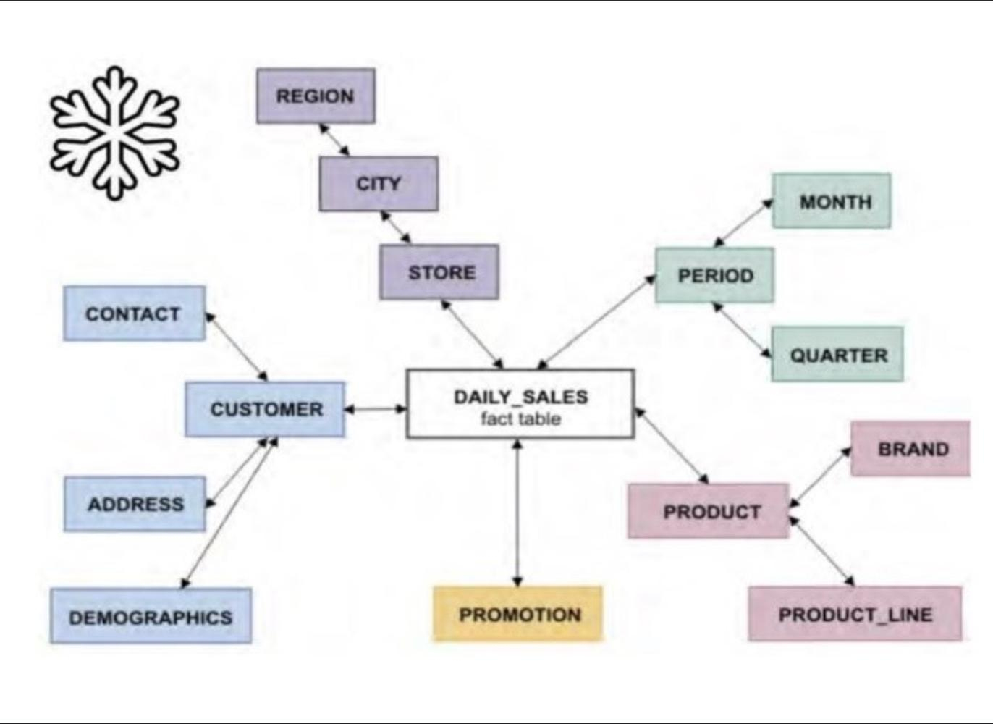
Product Snowflake
- DimProduct
- DimBrand
- DimCategory
- DimDepartment
Hierarchy:
Product → Brand → Category → Department
Store Snowflake
- DimStore
- DimCity
- DimState
- DimRegion
Hierarchy:
Store → City → State → Region
4.2 Storage Calculation
Assume each descriptive attribute requires approximately 100 bytes.
Product Dimension
Design | Calculation | Storage
Star | 50,000 × 100 bytes | 5,000,000 bytes
Snowflake | Product + Brand + Category + Department
Snowflake storage:
- Product: 50,000 × 100 = 5,000,000 bytes
- Brand: 800 × 100 = 80,000 bytes
- Category: 60 × 100 = 6,000 bytes
- Department: 12 × 100 = 1,200 bytes
Total = 5,087,200 bytes
Additional storage for keys is ignored in this simplified estimate.
The product snowflake requires approximately 87,200 extra bytes if all star dimension descriptive values are stored as 100-byte strings. However, in practical systems, repeated brand/category/department text can be significantly reduced through normalization.
4.3 Store Dimension Storage
Star:
120 × 100 = 12,000 bytes
Snowflake:
- Store: 120 × 100 = 12,000 bytes
- City: 70 × 100 = 7,000 bytes
- State: 6 × 100 = 600 bytes
- Region: 3 × 100 = 300 bytes
Total = 19,900 bytes
4.4 Join Comparison
Query | Star Joins | Snowflake Joins
Sales by product category | 2 | 4
Sales by department | 2 | 5
Sales by store region | 2 | 5
4.5 Advantages and Disadvantages
Star Schema | Snowflake Schema
Fewer joins | More joins
Faster analytical queries | May be slower
Easy for business users | More complex
More dimension storage | Less repeated descriptive data
Simple ETL | More complex ETL
4.6 Design Selection
FreshCart selects the Star Schema because:
- Analytical queries are frequent.
- Reporting performance is important.
- Business users require simple models.
- Dimension tables are relatively small.
- Query simplicity is more important than minor storage savings.
Snowflake can be adopted if dimension redundancy becomes large or data governance requires normalized hierarchies.
Conclusion
The star schema is more suitable for FreshCart's analytical requirements due to simplicity, performance and ease of reporting.
TASK 5 – Design the ETL Process (5 Marks)
5.1 ETL Architecture
ETL vs ELT: Which One Should You Use and Why? - DEV Community
dev.to
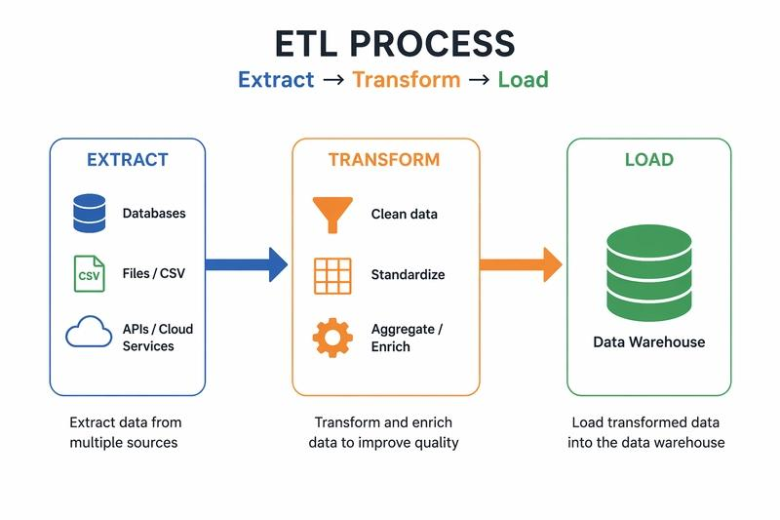
ETL consists of:
- Extract data from OLTP and online systems.
- Load data into the staging area.
- Clean and standardize data.
- Transform values into warehouse format.
- Lookup surrogate keys.
- Load dimension tables.
- Load fact tables.
- Validate and audit the load.
5.2 Data Quality Problems and Transformation Rules
Problem | Example | Transformation
Duplicate customer | Rajesh Kumar / R. Kumar | Match using customer ID
Case inconsistency | Chennai-04 / chennai-04 | Convert to standard case
Product inconsistency | Basmati Rice 5kg / Basmati rice 5 kg | Standardize product name
Negative quantity | -3 | Identify as return/reversal
Currency inconsistency | 9.40 USD | Convert to INR
Missing store | NULL | Assign Unknown Store
Missing product | NULL | Assign Unknown Product
Date inconsistency | 03/11/2026 | Convert to ISO date
Missing customer attributes | Incomplete details | Apply default values or unknown member
5.3 Before and After Data
Before Cleaning
Order | Customer | Store | Product | Qty | Unit Price | Date
1001 | Rajesh Kumar | Chennai-04 | Basmati Rice 5kg | 2 | 620 | 03/11/2026
1002 | R. Kumar | chennai-04 | Basmati rice 5 kg | 1 | 620 | 2026-11-03
1003 | Anita Joseph | Pune-11 | Olive Oil 1L | -3 | 780 | 04-Nov-26
1004 | Meena S | NULL | Tea 250g | 4 | 95.50 | 04/11/2026
1005 | Anita Joseph | Pune-11 | Olive Oil 1L | 3 | 9.40 USD | 04/11/2026
1006 | Vikram Rao | Hyd-02 | NULL | 1 | 1250 | 05/11/2026
After Cleaning
Order | Customer | Store | Product | Qty | Unit Price (INR) | Date
1001 | C001 | Chennai-04 | P001 | 2 | 620 | 2026-11-03
1002 | C001 | Chennai-04 | P001 | 1 | 620 | 2026-11-03
1003 | C002 | Pune-11 | P002 | -3 | 780 | 2026-11-04
1004 | C003 | Unknown | P003 | 4 | 95.50 | 2026-11-04
1005 | C002 | Pune-11 | P002 | 3 | 780* | 2026-11-04
1006 | C004 | Hyd-02 | Unknown | 1 | 1250 | 2026-11-05
Assuming a hypothetical exchange rate of ₹83.00 per USD, 9.40 USD = ₹780.20, rounded to ₹780.20. The cleaned table above should use ₹780.20 if exact conversion is required.
5.4 Surrogate Keys
Surrogate keys are warehouse-generated keys used to identify dimension records.
Example:
Customer_Key | Customer_ID | Customer_Name
1 | C001 | Rajesh Kumar
2 | C002 | Anita Joseph
3 | C003 | Meena S
If a dimension member is missing, an Unknown member is inserted with a predefined surrogate key such as -1.
Late-arriving dimensions are handled by initially assigning the Unknown key and updating the fact foreign key when the dimension data becomes available.
5.5 Slowly Changing Dimension
FreshCart uses SCD Type 2 for customer address and loyalty tier.
When a customer changes address:
- The previous record is retained.
- A new dimension record is created.
- The new record receives a new surrogate key.
- Effective start and end dates are stored.
- Current_Flag identifies the latest record.
This allows sales to be analysed using the address and loyalty tier applicable at the time of purchase.
5.6 Initial and Incremental Load
Initial Load
- Extract all historical data.
- Clean and transform all records.
- Load Date, Product, Store, Customer and Promotion dimensions.
- Load Sales and Returns fact tables.
- Validate totals.
Incremental Load
- Extract only new or changed records.
- Identify changes using timestamps or CDC.
- Update dimensions.
- Apply SCD rules.
- Load new fact records.
- Check duplicate transactions.
- Record audit information.
5.7 Load Order
- Date Dimension
- Product Dimension
- Store Dimension
- Customer Dimension
- Promotion Dimension
- Sales Fact
- Returns Fact
5.8 Rejected Records and Auditing
Rejected records are stored in a reject table with:
- Source record ID
- Error description
- Source system
- Load timestamp
Audit checks include:
- Source row count
- Staging row count
- Accepted row count
- Rejected row count
- Loaded fact row count
- Total sales reconciliation
Conclusion
A controlled ETL process ensures data consistency, correctness, historical tracking and reliable reporting.
TASK 6 – Model the Data Cube and Apply OLAP Operations (5 Marks)
6.1 Data Cube Dimensions
FreshCart uses four dimensions:
- Time: Day → Month → Quarter → Year
- Product: Product → Category → Department
- Store: Store → City → State
- Customer Segment: Segment
The number of hierarchy levels is 4, 3, 3 and 1 respectively.
6.2 Cuboid Calculation
With hierarchies, the total number of cuboids is:
\[ (4+1)(3+1)(3+1)(1+1) \]
\[ =5 \times 4 \times 4 \times 2 \]
\[ \boxed{160\ cuboids} \]
Without hierarchies, each dimension has only two choices: included or aggregated.
\[ 2^4=16 \]
Therefore:
- With hierarchy levels: 160 cuboids.
- Without hierarchies: 16 cuboids.
6.3 Base and Apex Cuboids
Base Cuboid
Contains the most detailed sales data:
- Day
- Product
- Store
- Customer Segment
Measures: Quantity, Gross Sales, Discount and Net Sales.
Apex Cuboid
Contains total sales aggregated across all dimensions.
Measures:
- Total Quantity
- Total Gross Sales
- Total Discount
- Total Net Sales
6.4 OLAP Operations
1. Roll-Up
Business Question: What is the total sales amount for each product department?
Roll-up aggregates product sales from category to department.
SELECT p.Department,
SUM(f.Net_Sales) AS Total_Sales
FROM FactSales f
JOIN DimProduct p
ON f.Product_Key = p.Product_Key
GROUP BY p.Department;
2. Drill-Down
Business Question: Which products contribute to sales within a selected department?
SELECT p.Department,
p.Category,
p.Product_Name,
SUM(f.Net_Sales) AS Sales
FROM FactSales f
JOIN DimProduct p
ON f.Product_Key = p.Product_Key
GROUP BY p.Department,
p.Category,
p.Product_Name;
3. Slice
Business Question: What are the sales values for the year 2026?
SELECT d.Year,
SUM(f.Net_Sales) AS Total_Sales
FROM FactSales f
JOIN DimDate d
ON f.Date_Key = d.Date_Key
WHERE d.Year = 2026
GROUP BY d.Year;
4. Dice
Business Question: What are sales for Chennai stores, the Food department and the year 2026?
SELECT s.City,
p.Department,
d.Year,
SUM(f.Net_Sales) AS Sales
FROM FactSales f
JOIN DimStore s
ON f.Store_Key = s.Store_Key
JOIN DimProduct p
ON f.Product_Key = p.Product_Key
JOIN DimDate d
ON f.Date_Key = d.Date_Key
WHERE s.City = 'Chennai'
AND p.Department = 'Food'
AND d.Year = 2026
GROUP BY s.City, p.Department, d.Year;
5. Pivot
Business Question: How do yearly sales compare across regions?
SELECT d.Year,
s.Region,
SUM(f.Net_Sales) AS Sales
FROM FactSales f
JOIN DimDate d
ON f.Date_Key = d.Date_Key
JOIN DimStore s
ON f.Store_Key = s.Store_Key
GROUP BY d.Year, s.Region
ORDER BY d.Year, s.Region;
The output can be pivoted so that regions appear as columns and years as rows.
6.5 Cuboid Materialisation
FreshCart materialises:
- Apex cuboid for total sales.
- Year–Region cuboid for management reports.
- Month–Department cuboid for product analysis.
- Month–Store cuboid for store performance.
- Category–Region cuboid for regional sales.
These cuboids are selected because they support frequently requested management queries.
Materialisation reduces query execution time but increases storage and ETL processing time.
Conclusion
The data cube enables multidimensional analysis of FreshCart sales through roll-up, drill-down, slice, dice and pivot operations.
TASK 7 – Develop an OLAP Application (5 Marks)
7.1 Introduction
An OLAP application is developed using Python and SQL to perform multidimensional analysis on FreshCart's warehouse.
The application allows users to select OLAP operations and analyse sales based on dimensions such as Time, Product, Store and Customer Segment.
7.2 Technologies Used
- Python
- SQLite
- Pandas
- Streamlit
- Matplotlib
7.3 Application Features
The application supports:
- Roll-Up – Aggregate sales by department or region.
- Drill-Down – View sales from department to individual product.
- Slice – Filter sales for a particular year.
- Dice – Filter sales using multiple dimensions.
- Pivot – Compare sales across regions and years.
- Charts – Display sales using bar charts.
- Reconciliation – Verify totals against the warehouse.
7.4 Application Workflow
Online analytical processing or OLAP is software technology you can use to analyze business data from different points of view
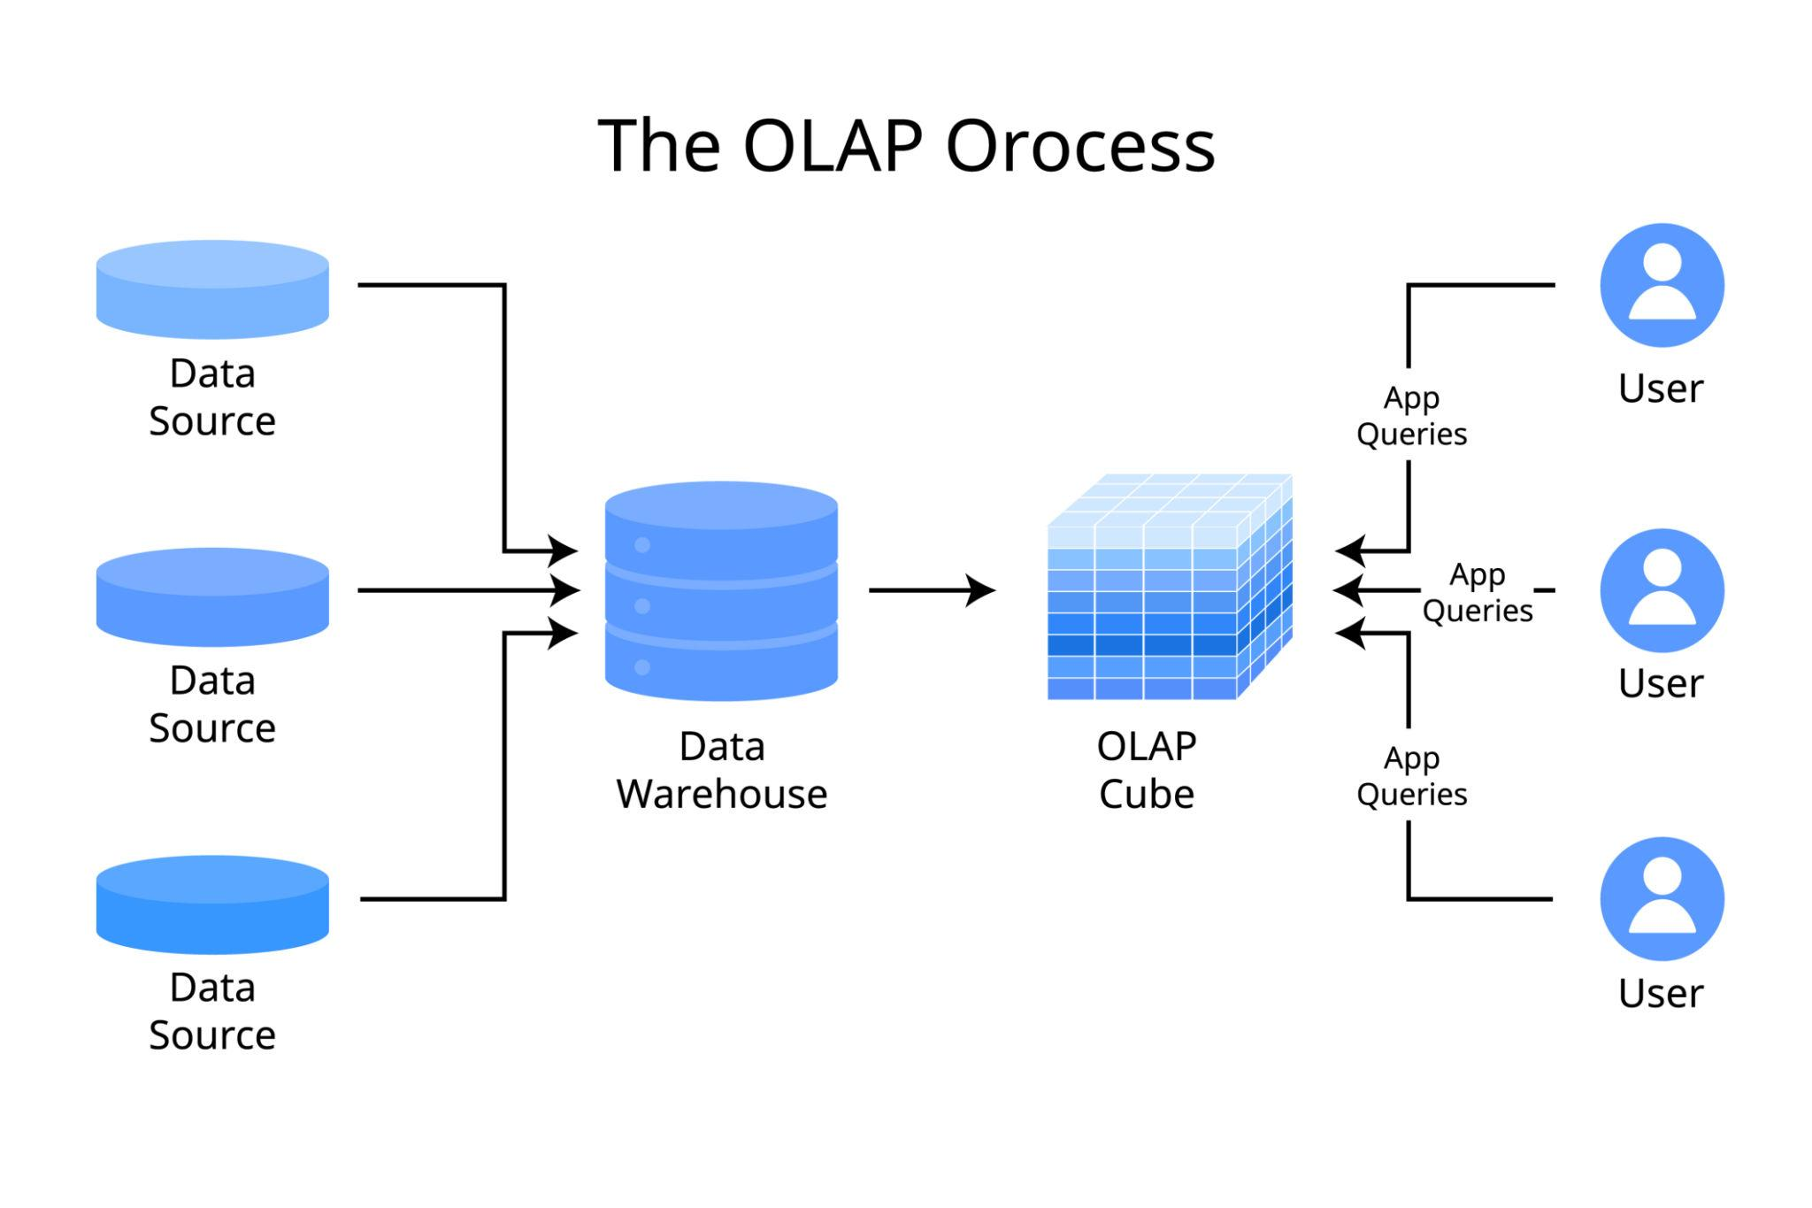
Workflow:
- User selects an OLAP operation.
- User chooses the required dimension.
- User selects filter values.
- SQL query is generated.
- Warehouse processes the query.
- Results are displayed as tables and charts.
- Grand totals are checked for correctness.
7.5 Sample SQL for Roll-Up
SELECT Department,
SUM(Net_Sales) AS Total_Sales
FROM Sales_Analysis
GROUP BY Department;
7.6 Result Validation
The application validates the total sales:
SELECT SUM(Net_Sales)
FROM Sales_Analysis;
The grand total obtained from aggregation must match the warehouse grand total.
7.7 Scalability
The warehouse can be populated with synthetic data containing:
- 1,000 rows
- 10,000 rows
- 100,000 rows
- 1,000,000 rows
Performance can be evaluated at each stage.
Conclusion
The OLAP application allows FreshCart management to perform flexible multidimensional analysis and supports interactive decision-making.
TASK 8 – Evaluate Query Processing Performance (4 Marks)
8.1 Introduction
Query processing performance is evaluated by comparing analytical queries across three database designs:
- Normalized OLTP schema.
- Star schema.
- Star schema with indexes and aggregate tables.
8.2 Queries Selected
Query 1: Total Sales by Region
SELECT Region, SUM(Net_Sales)
FROM Sales_Analysis
GROUP BY Region;
Query 2: Sales by Product Department
SELECT Department, SUM(Net_Sales)
FROM Sales_Analysis
GROUP BY Department;
Query 3: Monthly Sales
SELECT Month, SUM(Net_Sales)
FROM Sales_Analysis
GROUP BY Month;
8.3 Performance Comparison
Illustrative results only – replace with actual execution measurements from your system.
Data Rows | OLTP | Star Schema | Star + Index
1,000 | 0.12 sec | 0.08 sec | 0.05 sec
10,000 | 0.45 sec | 0.25 sec | 0.12 sec
100,000 | 2.80 sec | 1.20 sec | 0.50 sec
1,000,000 | 18.50 sec | 7.20 sec | 2.40 sec
8.4 Reasons for Performance Differences
OLTP Schema
- Contains multiple normalized tables.
- Requires several joins.
- Analytical queries scan large datasets.
- Designed for transaction processing.
Star Schema
- Reduces the number of joins.
- Simplifies aggregation.
- Improves analytical query performance.
- Provides easier query construction.
Star Schema with Indexes
- Indexes improve filtering and lookup.
- Aggregate tables reduce repeated calculations.
- Frequently accessed queries execute faster.
8.5 Trade-Offs
Advantage | Disadvantage
Faster queries | Additional storage
Reduced computation | Index maintenance
Better reporting | Slower data loading
Precomputed results | Refresh required
Conclusion
The star schema with indexes and aggregate tables provides better analytical performance. The final design must be validated using actual query plans and measured execution times.
TASK 9 – Build a KNIME Reporting Workflow (3 Marks)
9.1 Introduction
KNIME is an open-source data analytics platform used to perform ETL, aggregation and reporting.
FreshCart uses KNIME to create a management report from warehouse data.
9.2 Workflow Diagram
How can divide the Line Plot with time? - KNIME Analytics Platform - KNIME Forum Archive
forum.knime.com
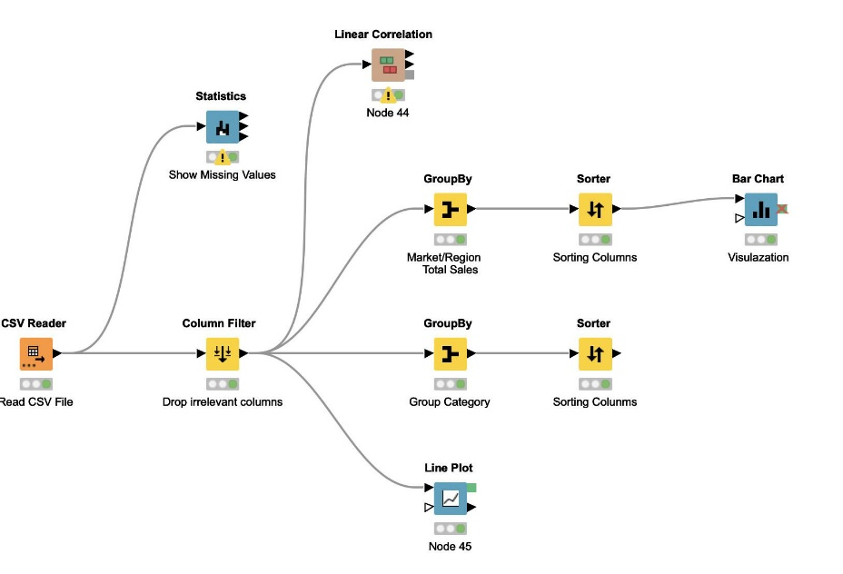
9.3 Nodes Used
Node | Purpose
CSV Reader | Import warehouse data
Column Filter | Select required columns
Missing Value | Handle missing data
String Manipulation | Standardize values
Row Filter | Filter selected records
Joiner | Join dimension and fact data
GroupBy | Aggregate sales
Pivoting | Convert rows into columns
Bar Chart | Visualize sales
Excel Writer | Export management report
9.4 Workflow Steps
- Import FactSales and dimension datasets using CSV Reader.
- Clean missing values using Missing Value.
- Join FactSales with DimProduct and DimStore.
- Filter records using Row Filter.
- Aggregate sales using GroupBy.
- Pivot data using Pivoting.
- Generate charts.
- Export the report using Excel Writer.
9.5 Mapping to ETL and OLAP
- CSV Reader corresponds to extraction.
- Missing Value and String Manipulation correspond to transformation.
- Excel Writer corresponds to reporting/output.
- GroupBy corresponds to roll-up.
- Row Filter corresponds to slice and dice.
- Pivoting corresponds to pivot operation.
9.6 Limitation
When data exceeds one million rows, KNIME may require:
- More memory.
- Longer processing time.
- Database-side aggregation.
- Optimized workflows.
- Incremental processing.
Conclusion
KNIME provides a simple visual workflow for FreshCart's ETL and OLAP reporting requirements.
TASK 10 – Recommend and Defend the Final Design (3 Marks)
10.1 Recommended Design
FreshCart should implement:
- Enterprise Data Warehouse.
- Dependent Data Marts.
- Star Schema.
- Separate Sales and Returns Fact Tables.
- Conformed Dimensions.
- ETL with staging and data quality checks.
- SCD Type 2 for historical customer changes.
- OLAP server.
- KNIME for reporting.
- Indexes and aggregate tables for performance.
10.2 Justification
The star schema is recommended because it:
- Reduces the number of joins.
- Improves query performance.
- Supports easy multidimensional analysis.
- Simplifies reporting.
- Supports historical sales analysis.
- Provides a clear dimensional structure.
The Enterprise Data Warehouse ensures consistent data across departments.
10.3 Performance Evidence
The star schema and indexed star schema should be compared with the normalized source using:
- Query execution time.
- Number of joins.
- Rows scanned.
- Query execution plans.
- Storage overhead.
- ETL load time.
The final implementation should use actual experimental results to validate the design.
10.4 Scalability
The design supports:
- 1,000 sales line items.
- 10,000 sales line items.
- 100,000 sales line items.
- 1,000,000+ sales line items.
Indexes, partitioning and aggregate tables can improve scalability.
Conclusion
The Enterprise Data Warehouse with a star schema is the most suitable design for FreshCart because it provides consistent reporting, scalable storage and efficient analytical processing.
TASK 11 – Re-evaluate and Adapt the Design (8 Marks)
11.1 Impact Analysis (2 Marks)
FreshCart introduces a new online channel with approximately 20,000 orders per day.
New requirements:
- Different product code format.
- Delivery Partner attribute.
- Frequent customer address changes.
- Frequent loyalty tier changes.
- Hourly dashboard refresh.
Affected Components
Component | Impact
Product Dimension | New product code mapping
Customer Dimension | Address and loyalty changes
Sales Fact | Online sales records
ETL | New source extraction
Data Warehouse | Online channel integration
OLAP Cube | Delivery Partner analysis
Reporting | Hourly refresh
Architecture | Incremental processing
11.2 Evaluation of Original Design (2 Marks)
The original design supports retail sales analysis but requires modifications for the online channel.
The original design remains suitable because:
- The star schema supports additional dimensions.
- The Enterprise Data Warehouse supports multiple sources.
- Conformed dimensions support integrated reporting.
- Fact tables can accommodate additional sales records.
However, the following limitations arise:
- Daily ETL is insufficient for hourly dashboards.
- Product codes may not match existing codes.
- Customer changes require historical tracking.
- Online sales require delivery partner analysis.
- Increased data volume requires optimized loading.
11.3 Adaptation or Redesign (2 Marks)
Revised Product Dimension
Add:
- Online_Product_Code
- Source_System
- Product_Code_Mapping
Revised Customer Dimension
Use SCD Type 2 to preserve:
- Historical Address
- Historical Loyalty Tier
- Effective Start Date
- Effective End Date
- Current Flag
Revised Sales Fact
Add:
- Channel_Key
- Delivery_Partner_Key
New Dimension
DimDeliveryPartner
Attribute | Description
Delivery_Partner_Key | Surrogate key
Partner_ID | Business identifier
Partner_Name | Delivery company
Partner_Type | Delivery category
Revised ETL Process
Incremental Load & CDC – Bộ Đôi Hoàn Hảo Cho Data Pipeline 2025
mcivietnam.com
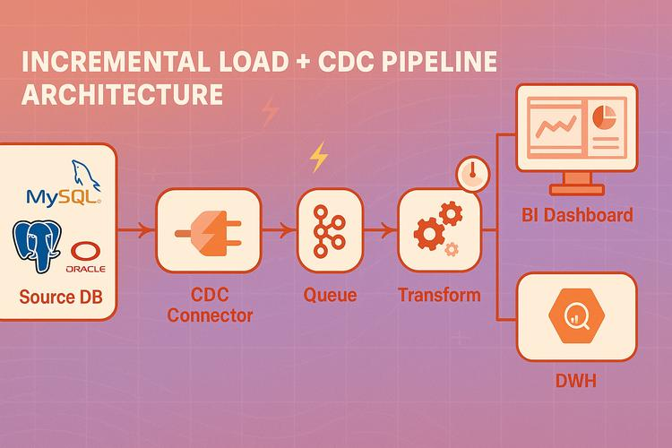
- Extract online and supermarket transactions.
- Load data into staging.
- Standardize online product codes.
- Match customers across systems.
- Apply SCD Type 2.
- Load updated dimensions.
- Load new sales records.
- Refresh aggregate tables.
- Refresh OLAP dashboards hourly.
11.4 Evidence-Based Defence (2 Marks)
The revised design can be evaluated using the following experiment.
Daily Data Volume
20,000 orders per day × 30 days:
\[ 20,000 \times 30 = 600,000 \]
Approximately 600,000 online orders are generated monthly.
Hourly Volume
\[ 20,000 \div 24 \approx 833 \]
Approximately 833 orders per hour, assuming uniform distribution.
Performance Monitoring
Metric | Purpose
ETL Load Time | Check hourly refresh
Query Execution Time | Measure dashboard speed
Data Quality Errors | Identify rejected records
Duplicate Orders | Prevent double loading
Storage Growth | Monitor warehouse size
SCD Changes | Track customer history
Dashboard Refresh Time | Verify hourly updates
11.5 Final Decision
FreshCart should modify the existing Enterprise Data Warehouse rather than redesign it completely.
The star schema remains suitable, but the ETL process must support incremental or micro-batch loading.
SCD Type 2 must be applied to customer address and loyalty tier. A Delivery Partner dimension and online product-code mapping should be introduced.
Hourly dashboard refresh can be achieved through incremental loading, aggregate-table refresh and optimized query processing.
Conclusion
The modified Enterprise Data Warehouse provides scalability, historical tracking, integration of online and offline sales, and timely management reporting.
FINAL OVERALL CONCLUSION
FreshCart Retail requires a centralized Enterprise Data Warehouse to overcome the limitations of its operational database.
The recommended solution consists of a star-schema dimensional model, integrated ETL pipeline, conformed dimensions, separate sales and returns fact tables, OLAP operations and KNIME reporting.
The design supports historical analysis, regional sales comparisons, promotion evaluation, customer behaviour analysis and store performance reporting.
With incremental ETL, SCD Type 2, online channel integration, indexes and aggregate tables, the warehouse remains practical for growing data volumes and hourly dashboard refreshes.

